**Fragen ISD**

# Datamanagement

(1) What is Data?

(a) Data are commonly understood to be the raw material produced by abstracting the world into categories, measures, and other representational forms –numbers, characters, symbols, images, sounds, electromagnetic waves, bits –that constitute the building blocks from which information and knowledge are created.

(b) Data are characteristics or information, usually numerical, that are calculated

(c) Data are understood to be the raw material produced by abstracting the world into categories, measures, and other representational forms –numbers, characters, symbols, images, sounds, electromagnetic waves, bits –that not constitute the building blocks from which information and knowledge are created.

(d) Data are a collection of numbers, raw material from a process output which allows to analyse the process and get the process leaner

(2) Which of the following is the quantitative data form “interval” ?

(a) blue eyes, brown eyes, green eyes, grey eyes

(b) five star rating

(c) pictures

(d) 15 degrees, 31.10.2020

(3) Which of the following are getting Ehaust data?

(a) log-files, website click paths

(b) observation, survey, cameras, scanners, sensors

(c) aggregations of data

(d) data collection from nature (huge amount)

(4) Which of the following is not an attribute of Data?

(a) Sharable

(b) Transportable

(c) Secure

(d) unauthorized

(5) What is a Schema also called?

(a) State

(b) Inference table

(c) Intension

(d) Extension

(6) What is shown here?

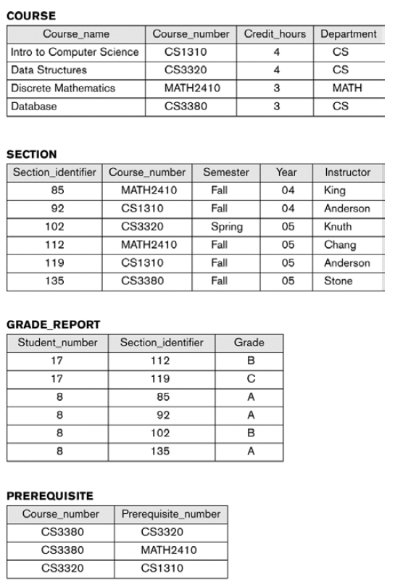

(a) ER Module

(b) Database State

(c) Database Schema

(d) Two Tier Client Server Architecture

(7) Which level is not defined by the three-level architecture in the DBMS schemas?

(a) Internal schema

(b) Conceptual schema

(c) External schemas

(d) Content schemas

(8) Why mappings among schema levels are needed?

(a) Data flow

(b) Processing requests and data

(c) Security

(d) Processing references

(9) What is also called a declarative language?

(a) High Level or Non -procedural Language:

(b) Low Level or Procedural Language:

(c) Middle Level or Procedural Language:

(d) SQL

(10) Which of the following Three-tier Architecture do not enhance security?

(a) Database server only accessible via middle tier

(b) Clients contain user interfaces and/or web browsers

(c) Clients can always directly access database server

(d) The client is typically a PC or a mobile device connected to the Web

(11) What stage of a normal form is this?

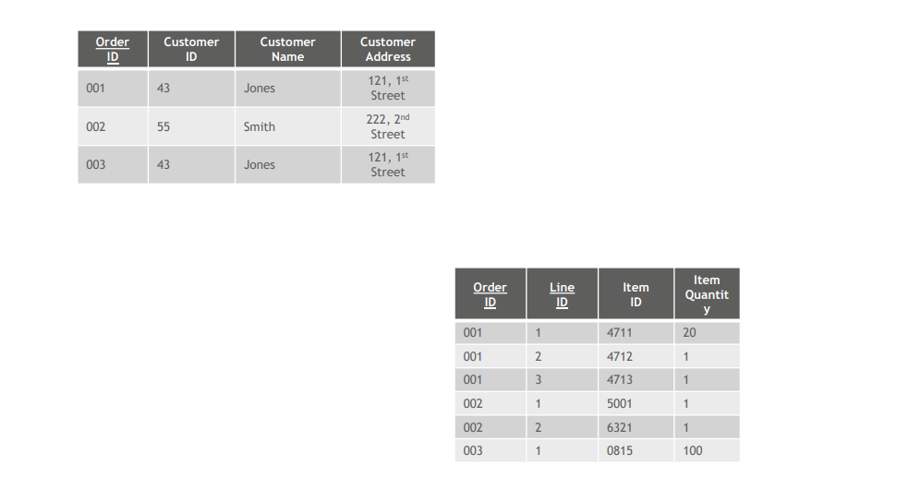

(a) 1 NF

(b) 2 NF

(c) 3 NF

(d) None of them

(12) What is the primary key in the image below??

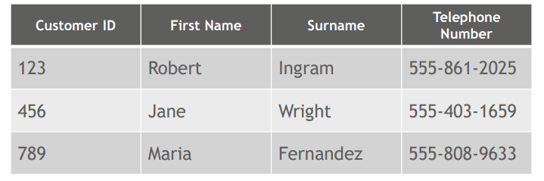

(a) Customer ID

(b) First Name

(c) Surname

(d) Telephone Number

(13) What kind of model is this?

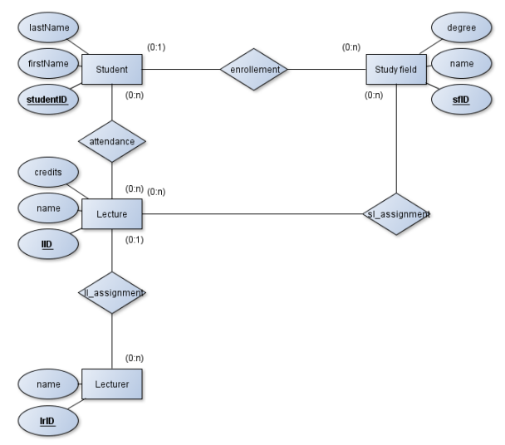

(a) Sequenz Diagram

(b) Class Model

(c) ER Model

(d) UML Model

(14) What do you have to know in a 1:n relation?

(a) Add the primary key from the 1:n table to the 1:1 table as an primary key

(b) In the 1:n table is a foreign-key

(c) Add the primary key from the 1:n table to the 1:1 table as an foreign key

(d) Both primary keys stay as an additional foreign key in their respective tables

(15) What do you have to know in a n:m relation (see image below)?

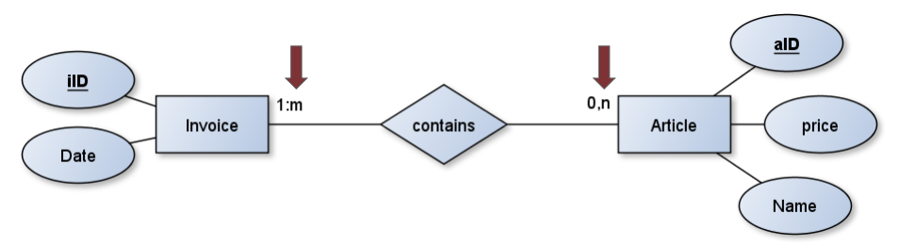

(a) Relation becomes not an additional table

(b) Tables holds two lines per relation

(c) Add the primary key from the 1:m table to the 0:n table as an foreign key

(d) Primary key is the combination of both primary keys of the entity tables

# Business Statistic

(1) What is the difference between a “Parameter” and a “Statistic”?

(a) A Statistic is a characteristic measured for a population. A Parameter is a characteristic measured for a sample

(b) A Parameter is a characteristic measured for a population. A Statistic is a characteristic measured for a sample

(c) A Parameter is a specific value in a formula and statistics is the teaching of methods for handling quantitative information

(d) A Parameter is a value that we are interested in studying and analyzing in our current work. A Statistic is the whole work

*This problem is primarily discussed in Video #1 in this week’s series of six lecture videos*

(2) Which of these answers has the right values for the “Five Number Summary”?

* + 1. Minimum value, lower quartile, mean, upper quartiles and maximum value
    2. Minimum value, lower quartile, third quartile, upper quartile and maximum value
    3. First quartile, median, upper quartile, 90th percentile and maximum value
    4. Minimum value, lower quartile (first quartile), median, upper quartile, maximum value

*This problem is primarily discussed in Video #1 in this week’s series of six lecture videos*

(3) What is the definition of mean?

(a) The mean (informally, the “average“) is found by ordering the set from lowest to highest and finding the exact middle. The median is just the middle number: 10 + 10 + 20 + 40 + 70 🡪 20

(b) The mean (informally, the “average“) is found by adding all of the numbers together and dividing by the number of items in the set: 10 + 10 + 20 + 40 + 70 / 5 = 30.

(c) The mean (informally, the “average“) is the sum by ordering the set from lowest to highest and and calculate how many values there are 10 + 10 + 20 + 40 + 70 🡪 5

(d) The mean (informally, the “average“) is the value that appears most often in a set of data values

*This problem is primarily discussed in Video #1 in this week’s series of six lecture videos*

(4) What is the definition of median?

(a) The median (informally, the “average“) is found by ordering the set from lowest to highest and finding the exact middle. The median is just the middle number: 10 + 10 + 20 + 40 + 70 🡪 20

(b) The median is found by ordering the set from lowest to highest and finding the exact middle. The median is just the middle number: 20..

(c) The median (informally, the “average“) is the sum by ordering the set from lowest to highest and and calculate how many values there are 10 + 10 + 20 + 40 + 70 🡪 5

(d) The median (informally, the “average“) is the value that appears most often in a set of data values

(5) What is the probability that an airplane is arriving on time (take a look at the joint probability table)?

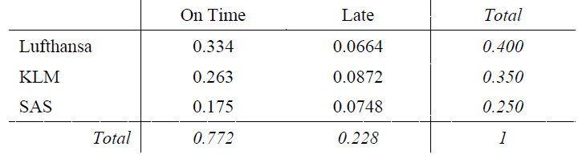

(a) 0.400

(b) 0.228

(c) 0.334

(d) 0.772

(6) Which of these variables is classify as a “Discrete” variable?

(a) The number of multiple-choice questions a student gets correct on a twenty-question examination.

(b) How long (in seconds) it takes you to roll a “seven” three times in row with a pair of dice.

(c) How long (in minutes) you exceed 160 km/hour when driving on the autobahn for two hours.

(d) The time a car needs to pass a bridge.

*This problem is primarily discussed in Video #6 in this week’s series of six lecture videos*

(7) Which of the following is a exponential situation?

(a) An auditor visits an average of 4.25 clients per month. Find the probability that this auditor visits exactly three clients this month.

(b) The average time between hail-storms is fourteen weeks. A farmer plans to harvest a field two months from now. Find the probability that there will be a hail-storm prior to this harvest.

(c) Suppose a stock-broker executes an average of 28.59 trades each hour. Find the probability that this stock-broker will execute exactly ten trades in the next twenty minutes.

(d) An executive at an insurance company learns that 11% of all automobile insurance claims are fraudulent. Find the probability that two or more of the next twelve claims are fraudulent.

*These portions are primarily discussed in Videos 2, 3, and 4 in this week’s series of six lecture videos.*

(8) What measures the binomial distribution?

(a) How far away from the mean the values tend to fall

(b) The expected time for an event to occur

(c) The number of successes in a sequence of *n*

(d) How many times an event is likely to occur within x periods of time

(9) How do you know which values of a forecast in a time period was better?

(a) The more time periods are calculated, the better is the forecast

(b) The bigger the value of the forecast error is to zero, the better the forecast value was for the time period

(c) The smaller the average value of Et2 is for all time periods, the better the forecast in a time period

(d) The closer the value of the forecast error is to zero, the better the forecast value was for the time period

(10) What is the Weighted Moving Average method that is equivalent to MA(4)?

(a) WMA (1/4, 1/4, 1/4, 1/4)

(b) WMA (1, 1, 1, 1)

(c) WMA (4, 4, 4, 4)

(d) WMA (4/1, 4/1, 4/1, 4/1)

# Information System Modelling

***ISM Questions (20)***

(1) Which statement is wrong regarding software processes. All software processes should involve

(a) Specification – defining what the system should do

(b) Design and implementation- defining the organization of the system and implementing the system

(c) Roles

(d) Validation and Evolution

(2) The waterfall model

(a) Is an incremental model

(b) Belongs to the agile software development

(c) is really flexible

(d) is simple and easy to explain to customers

(3) A project is/does

(a) Characterized by the uniqueness of its conditions (objectives, demarcation, organization, resources, etc…)

(b) Not require lots of planning and coordination

(c) No limited in time by defined start and end dates

(d) Riskless

(4) Why is project management so special? (which answer is wrong)

(a) The product is instangible

(b) Software processes are static

(c) Many software projects are “one-off” projects

(d) Software processes are variable and organization specific

(5) What can the project manager do to intervene in case of delays?

(a) Just go on without contacting the management

(b) Lengthen the critical path

(c) Omit features or move to the next release

(d) More quality

(6) What is meant by risk management?

(a) Has nothing to do with danger and the risk of loss

(b) Cannot become a real challenge

(c) Risk management is always in the same state

(d) Identifying risks and drawing up plans to minimize their effect on a project

(7) Which statement is not true concerning agile methods?

(a) Focus on design

(b) Focus on the code

(c) Iterative approach to software development

(d) Intended to deliver working software quickly and evolve this quickly to meet changing requirements

(8) Principles of agile methods. Which statement is true?

(a) System requirements won’t change

(b) It’s not necessary to keep the maintenance process simple

(c) Customer involvement

(d) Processes not people

(9) What is meant by extreme programming?

(a) Extremely fast programming without breaks

(b) New versions may be built several times per day

(c) Big releases

(d) Test- second development

(10) What is a benefit of Scrum?

(a) Unstable requirements hold up progress

(b) Not the whole team has visibility of everything

(c) The product is seen in a whole

(d) Trust beween customers and developers is established and a positive culture is created in which everyone expects the project to succeed

(11) Scaling out and scaling up- Which statement is true?

(a) Scaling up is concerned with using agile methods for developing small software systems

(b) Scaling out is concerned with how agile methods can be introduced across small organizations

(c) Scaling up is concerned with using incremental methods

(d) Scaling out introduces agile methods across a large organization

(12) Why agile? One statement is false.

(a) Customers as vague ideas/ vision at the beginning

(b) Systems are less integrated

(c) Technology stack is more compley

(d) User have much higher expectations regarding the usability of the system

(13) Agile…

(a) Does replace management

(b) Is easy to understand but hard to apply

(c) Do not require a certain degree of self- organization

(d) Culture is in every organization

(14) Non- functional requirments can be… (mark to wrong one):

(a) Product requirements

(b) Organizational requirements

(c) A requirement that specifies a function that a system must be able to perform

(d) External requirements

(15) How can requirements be elected?

(a) There is no need to elect them, since they are clear from the very beginning

(b) Interview just one important group of people

(c) Talking to various stakeholders

(d) Just add requirements what you think is important without asking for other peoples opinion (could be too complex then)

(16) User requirements:

(a) Are statements in natural language plus diagrams of the services the system provides and its operational constraints

(b) Structured document setting out detailed descriptions of the system’s functions, services and operational constraints

(c) Defines what should be implemented so may be part of a contract between client and contractor

(d) Can just be understood by people with technical background

(17) Which statement is wrong regarding system modelling?

(a) System modelling is the process of developing abstract models of a system, with each model presenting a different view or perspective of that system

(b) System modelling has now come to mean representing a system using some kind of graphical notation which is now almost always based on notations in the UML

(c) System modelling helps the analyst to understand the functionality of the system and models are used to communicate with customers

(d) System modelling is not really helpful to show the functionality of a system to the customer

(18) What is a domain model?

(a) A complex class diagrams

(b) Describes verbally how all these different terms relate to each other

(c) A live dictionary of all terms used in the project

(d) Shows specified relationships between the domain classes

(19) What is a robustness diagram? (which statement is false)

(a) Is basically a simplified UML communication diagram

(b) Forces to tie the use case text to the domain objects

(c) Fills the gap between the analysis phase (“what”) and the design phase (“how”)

(d) Ensures that the use case is not written in the context of the domain models

(20) Rules in Robustness Analysis. Which statement is correct?

(a) Nouns can talk to other nouns

(b) Verbs cannot talk to nouns

(c) Verbs can talk to verbs

(d) Controllers are nouns

# Management Information Systems

***MIS (10)***

(1) Considering Digital Transformation…

(a) The use of technology is not necessary to improve performance of enterprises

(b) Digital interaction means developing new digital value chains

(c) Digital distribution is an incorporation of digital materiality into physical objects

(d) One of the successful themes for economic growth is data, that is often considered as a catalyst for overall economy growth, innovation and digitalization across all economic sectors

(2) What is meant by Modularity?

(a) How a system is devided into subsystems and how these subsystems interconnect

(b) Brings unique content to systems

(c) Dynamics

(d) No final whole design of digital modules

(3) What is the correct order of the stages of Innovation?

(a) Development- discovery- diffusion- impact

(b) Discovery- development- diffusion- impact

(c) Diffusion- discovery- impact – development

(d) Discovery- diffusion- development- impact

(4) What is a Process Innovation?

(a) Significantly new products or services that are embodied in IT or enabled by IT

(b) Significantly new way of creating and capturing business value that is embodied in or enabled by IT

(c) A new way of doing things in an organizational setting

(d) CRM/ERP Systems

(5) What is B2B E-Commerce?

(a) To describe all types of inter- firm trade to exchange value across organizational boundaries

(b) The relationship between customers and organization

(c) That portion of B2B commerce that is not enabled by the internet and mobile apps

(d) B2B E- Commerce equals B2C E- Commerce

(6) What Statement is wrong. Potential Benefits of B2B E-Commerce…

(a) Improving quality of products by increasing cooperation among buyers and sellers and reducing quality issus

(b) Reduce inventory costs by increasing competition among suppliers

(c) Less price transparency

(d) Decreases product cycle time by sharing designs and production schedules with suppliers

(7) Five Basic Kinds of Organizational Structure. Which statement is not true?

(a) Entrepreneurial: small start- up businesses

(b) Adhocracy: law firms, school systems, hospitals

(c) Machine bureaucracy: midsize manufacturing firm

(d) Divisionalized bureaucracy: fortune 500 firms

(8) Organization Information Processing Theory. Which statement is wrong?

(a) This Theory identifies three important concepts: Information process needs,

Information process capabilities and the fit

(b) The organization needs Information to cope with environmental uncertainty and improve their decision making

(c) A strategic to cope with uncertainty would be to implement strucutural mechanisms and information processing capability to enhance the information flow and thereby reduce uncertainty

(d) An other strategic would be to reduce buffers to reduce the effect of uncertainty

(9) What is a ERP System?

(a) Integration of business processes in manufacturing and production, finance and accounting, sales and marketing and human resources into a single software system

(b) Enterprise Requirement Planning

(c) Business Resource Planning

(d) ERP is a worldwide acting company

(10) What are main factors why ERP- Project might fail? (which answer is wrong)

(a) Social commitment

(b) Lack of Alignment of ES and BPs

(c) Lack of in-House skills

(d) The ERP- Project team should consist of just a few people and should not communicate too much with others

# - Business Process Management (Claudia)

***BPM Questions (20)*** Claudia

(1) What is a Process?

(a) The transformation of Input to Output

(b) An alignment between costs and effort

(c) Another word for “strategy”

(d) The difference between technology now and then

(2) People in the field of BPM are not very interested in:

(a) How can we teach processes to one another?

(b) How can we show processes to one another?

(c) What is the general approach for business processes?

(d) How can we make people follow processes?

(3) What is not situated in the level of processes?

(a) KPI

(b) Organization Goals and measures of organizational sucess

(c) Process design and implementation

(d) Management of the process

(4) What is meant by role design?

(a) The question of Why people are leaving a process?

(b) Monitoring of failure and success

(c) The need of KPI’s

(d) Distribution of responsibility: how can tasks and responsibilities can be distributed in a process?

(5) What is process science?

(a) Interdisciplinary study of processes that is sequence of actions and events which take effect over time and in context

(b) Alignment between processes and physics

(c) Research and development

(d) Building environmentally friendly processes

(6) What is the Power of the process?

(a) A process is always super easy to handle

(b) There is no abstract from to real world to a mini world needed

(c) A process is always in the same state, it never changes

(d) A process makes an organization fit, increases the effectiveness of an organization and is really innovative

(7) What is most important in case of managing a process?

(a) To show everything in a process, no detail should be left out

(b) Complex management: it is important to cluster, abstract and structure

(c) Time management

(d) There should be as many main processes as possible

(8) What is BPM not about?

(a) Modelling

(b) Performance Measurement

(c) Risk Management

(d) Culture

(9) BPM should…

(a) Be done in every organization, doesn’t matter the business or the size of the organization

(b) Just include a few people

(c) Never consist any changes

(d) *deliver Business Value through driving business*

(10) Which one is not part of the six core capabilities?

(a) BPM Governance

(b) BPM Finance

(c) BPM Culture

(d) BPM Technology

(11) The BPM Culture includes…

(a) Infrastructure

(b) Values

(c) Skills

(d) Roles

(12) The BPM Technology includes…

(a) Solutions

(b) Models

(c) Roles

(d) Strategy

(13) Why is it important to have a context awareness?

(a) Because BPM should stick to a general cookbook approach

(b) Because BPM should be done just in the sake for doing it

(c) Because BPM should fit to the organizational context

(d) Context awareness is not relevant at all

(14) Which statement is wrong considering a Model?

(a) It is a representation

(b) It is a reductiveness

(c) It is purposefulness

(d) It is not an abstraction

(15) What are core processes about?

(a) How do we get the core processes work?

(b) What is needed to give the system the right direction?

(c) What value is it delivering for its customer?

(d) They are the bottom of the Retail H-Model

(16) Which connection is not allowed?

(a) A is not allowed:

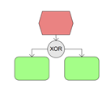

(b)

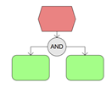

(c)

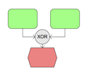

(d)

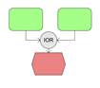

(17) Which statement is correct?

(a) two events can follow each other

(b) XOR: you can go both way A and B

(c) There is always a Start and End Function

(d) IOR: you can go both way A and B

(18) What is important when it comes to digital value creation?

(a) It is just about buying an ERP- System

(b) It is important to think beyond the technology, what is the interest of the people?

(c) It doesn’t matter what other people in the organization think

(d) Technology the way it is, is enough

(19) Which statement regarding disruptive technology is not correct?

(a) We can always improve, but technology gives us a roof

(b) Rethink the technology frame

(c) Innovation vs. Improvement

(d) It is always better to innovate than to improve

(20) What is meant by “data is the new oil”?

(a) The data itself is useful

(b) Everything is always valued

(c) Data is just valued if we analyse it, if we look inside

(d) There is no need for data at all